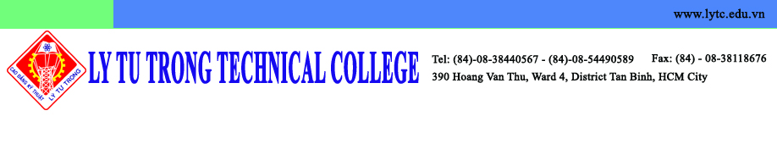

Kunsan National University
Institute of International Affairs & Language Education
558 Daehak Road, Gunsan, Jeollabukdo, 573-701, Korea

May 22, 2015

Dear Dr. Seman PYO, Director of Institute of IALE,

On behalf of Ly Tu Trong Technical College, I was very honored to have a chance to welcome you to visit our campus. To my deep regret I wasn’t there to welcome you due to my business trip.

This visit contributed to promoting cooperation between Kunsan National University (KNU) and Ly Tu Trong Technical College (LTTC), including the MOU and agreement for students and faculty exchange.

All programs are perfectly appropriate for students at our college. Besides I respectfully propose an internship for last-year students at KNU. This will open a great opportunity for the students to gain valuable experiences at one of the best universities in Korea while integrating into the unique Korean language and culture.

Thus, I am intensely hoping that we promote the Korean language co-training program. There are no words to show my appreciation for your cooperation in providing a well-qualified Korean course for the students so that they can be well-prepared for their study at KNU. We need to promote an open exchange of ideas and detailed information based on mutual benefit. All related documents will be sent to you by emails as soon as possible.

I am looking forward to paying a visit to KNU in return to your goodwill for visiting LTTC. I would be grateful if you could inform me about the convenient time for you.

Sincerely yours,

Dr. Pham Huu Loc
Rector of Ly Tu Trong Technical College
Ho Chi Minh City

